Jorge Javier Mejorada Hernández. Tuesday, Junuary 10, 2023.

* WEB FUNDAMENTALS
* WEEK 01.
* **URL:** Uniform Resource Locator.
* **HTML** and **CSS** are front-end languages.
* **Php** and **Python** are examples of back-end languages.
* **Screen readers**
* The **HTML** elements are shown in red with angle brackets **<body>, <h1>, <h2>, <p>** Opening and closing tag.
* **Nesting:** It’s tags inside other tags (**Child tags).**
* **HTML:** Hyper Text Markup Language.
* **HTML:** It’s not a programming language, is a markup language.
* We can write **HTML** code anywhere.
* The first line is a document line declaration **<!DOCTYPE html>**

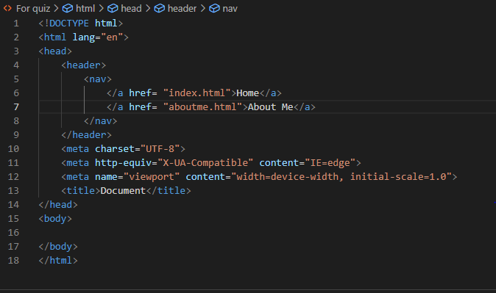

* **HTML:** is always in lowercase.

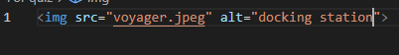

* This element don’t have an opening and a closing tag.
* Two **attributes** the **SRC (Source) or Alt (Alternative Text).**
* **HTML** handles the structure of the page, and **CSS** handles how it’s presented or how it looks.
* **CSS** is the language used to style an **HTML** document. It describes how the **HTML** should be displayed.
* **C**ascadian

**S**tyle

**S**heets

* You should always keep your **HTML** and **CSS** separated, if possible.
* The **HTML** element is used to tell our **HTML** page which **CSS** file is used to style your page.

You can have multiple **CSS** files affecting one **HTML** page.

**WORKBOOK**

* **WEEK 02: UNDERSTANDING CSS**
* **CSS Intro:** Cascading Style Sheets
* **CSS** stands for cascading style sheets. It is a style sheet language used to layout and style web pages.

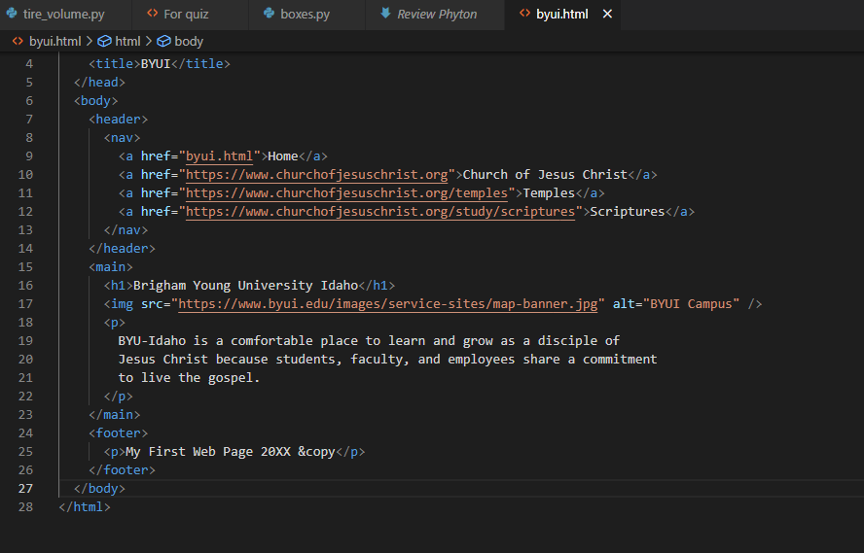

* **HTML** file

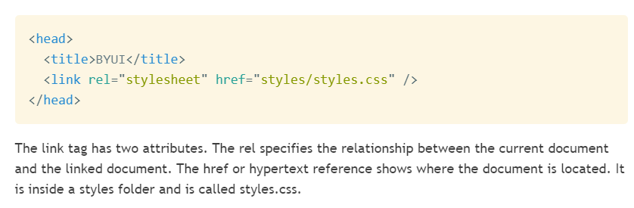

* **This is the first line of the CSS file.**

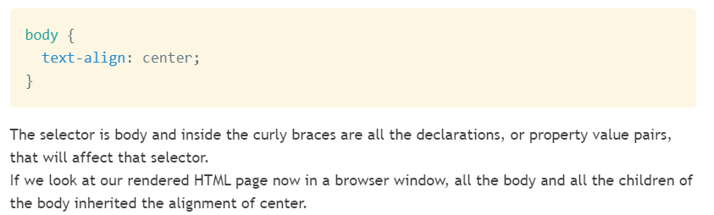

* **Result in the browser window:**

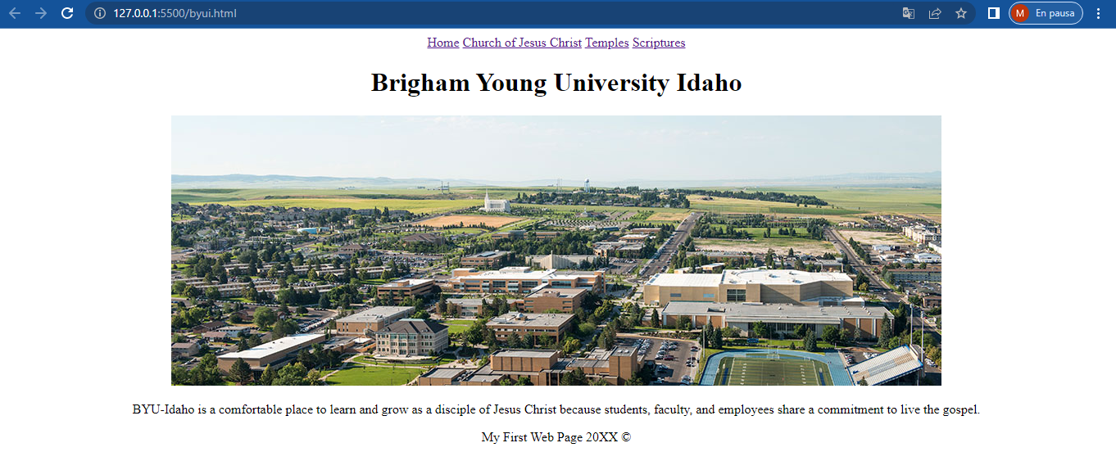

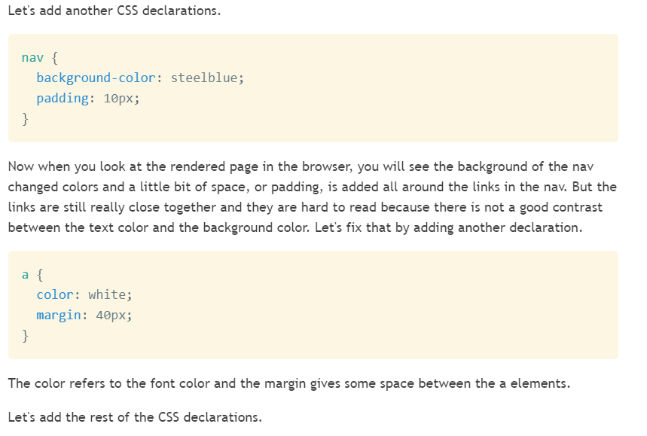

* **Result in the browser window:**

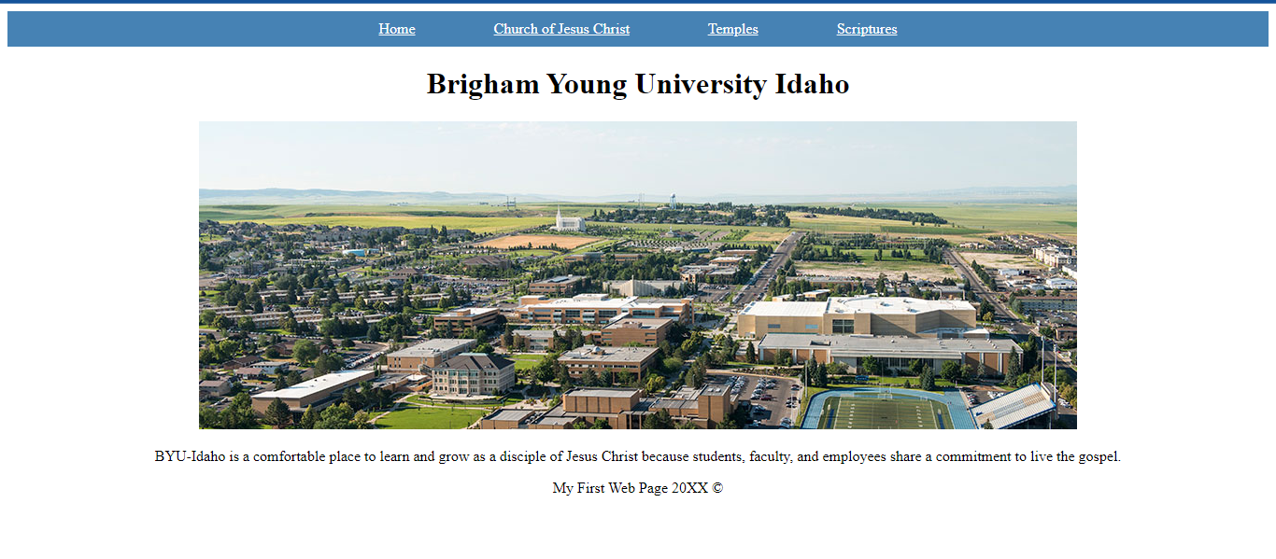

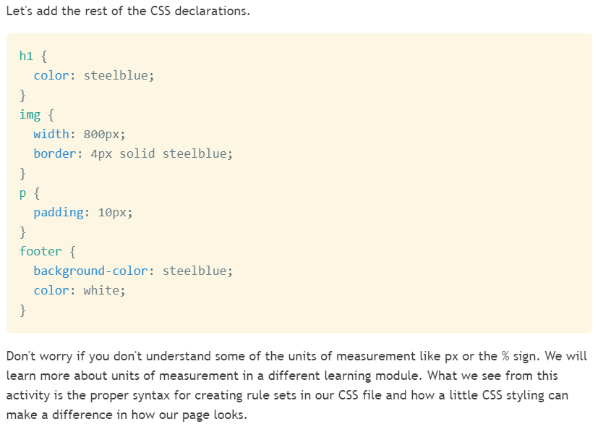

* **Result in the browser window:**

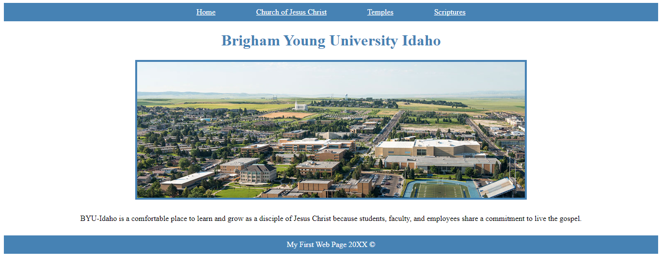

* **WEEK 03: WIREFRAME TO HTML.**
* **Class in HTML:** There are placed inside the beginning tag of the element**: <p class=”anyname”>** This is a wonderful paragraph **</p>** Later when **CSS** is use the ID and Class values can be used to target that element: **.anyname {color: green; }** And the other elements would not be affect.

**Class in HTML Calling the class instead <p> in CSS**

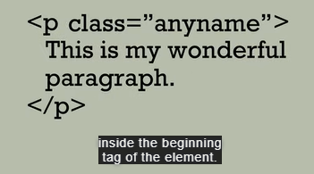 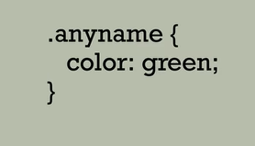

* **‘shaded’** is the class we want to set a background-color, so in CSS we put a dot, then the class and after that we put the **property name** and **the value, don’t foget the brackets.**

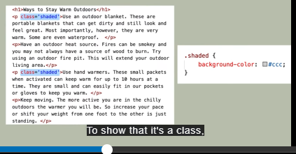

**Result:**

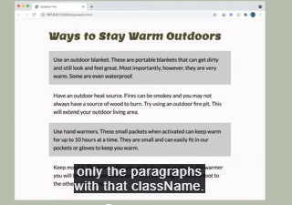

* **ID in HTML** means we are setting apart the elements of our code one by one, and all the ID’s should be different.

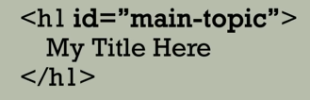 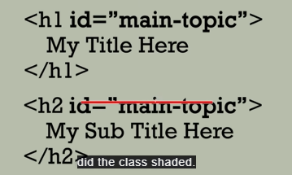

* **To apply it in CSS** we use a # and then the ID name



* **In HTML** you can use more than one **Class** in the same element, example:

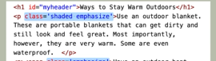

* There we see that the **Class names** are ‘shaded’ and ‘emphasize’, so you can call that <p> element in **CSS** as one or another.
* You can even have an **ID** and a **Class** in a same element and call it when needed.

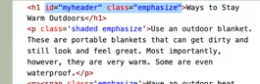

* **W3C Validation** is a great way to debug your HTML file.

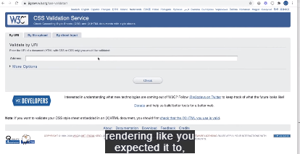

* **Wireframe** anticipates how a web page is going to look like, example:

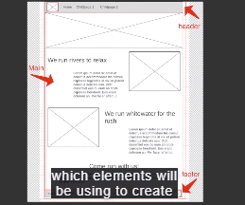

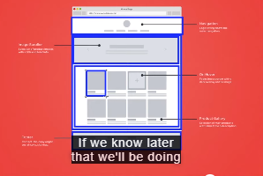

* **Class and ID Selectors**

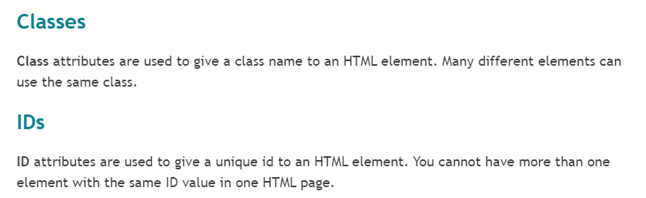

* **Working with Wireframes**

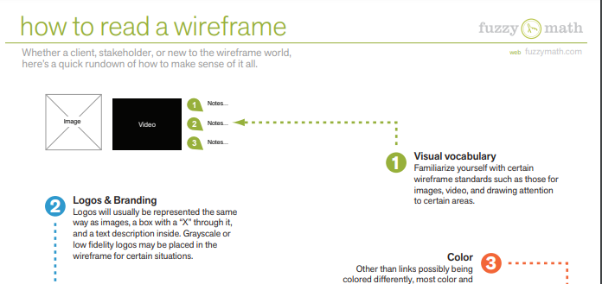

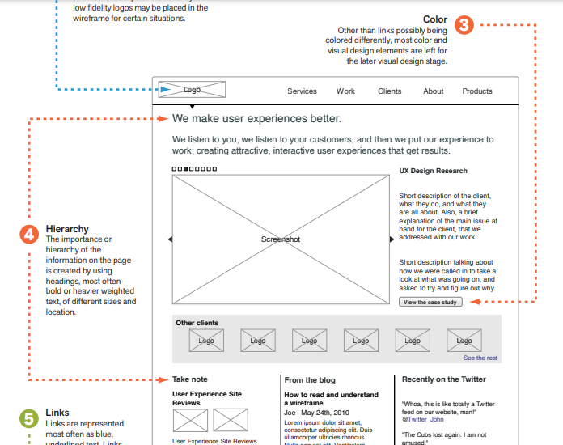

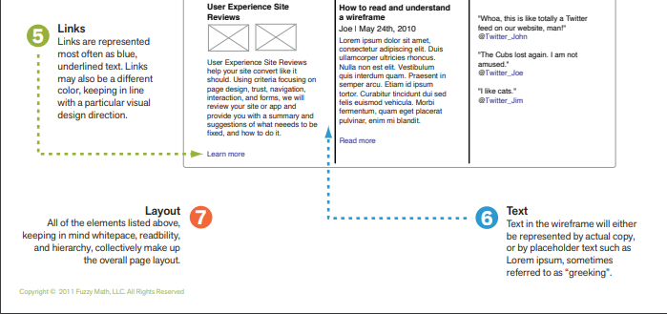

* **IMPORTANT FOR THE WIREFRAME!!!!**

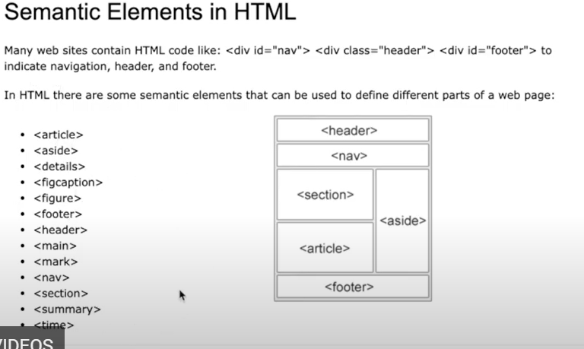

* **Some code HTML for the wireframe:**

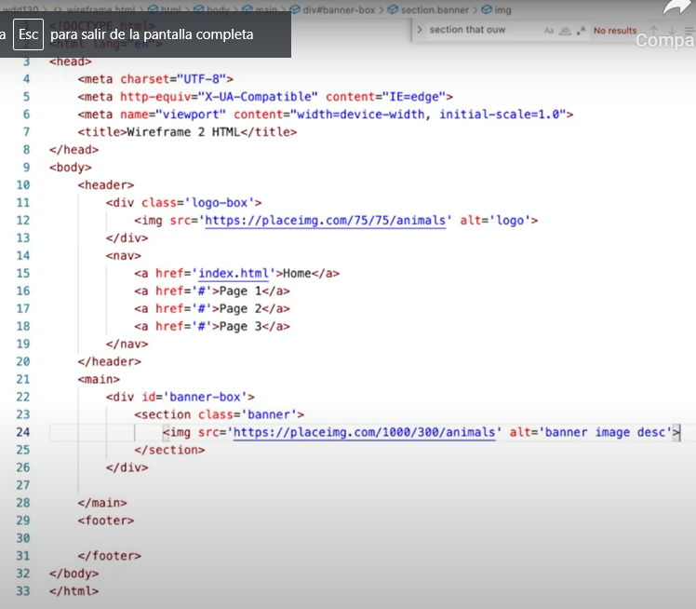

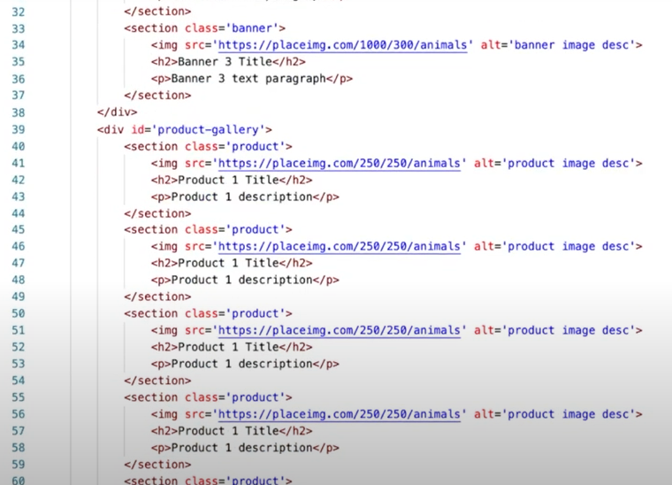

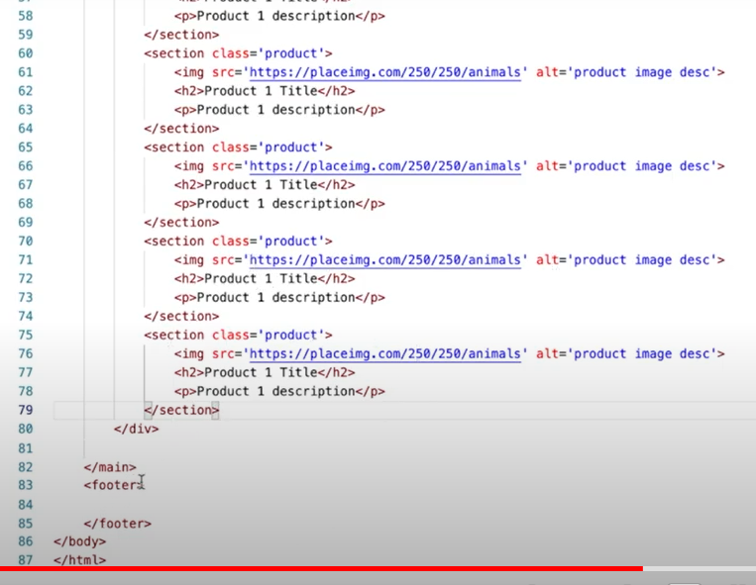

* **ELEMENTS FOR THE HTML CODE:**

**https://www.w3schools.com/html/html5_semantic_elements.asp**

* **Need some placeholder images in HTML if you don't have your images picked out yet?**

[**https://placeimg.com/**](https://placeimg.com/)

* **Troubleshooting.**
* **Validating is easy.** Go to **https://validator.w3.org/,** then enter in the same url that you would submit in iLearn for your site. It will check for any HTML errors and tell you where they are. Don't panic if it comes back with some really high number. One error can often cascade and create many others. I recommend fixing the first, then re-validating until all are gone.
* **Validate your CSS!** There is also a CSS standard, so you can validate that as well to check for errors. The process is similar, you just need to go to a different site. The CSS validator can be found at: **https://jigsaw.w3.org/css-validator/.** Follow the same steps...fix the first error then re-validate until clean.
* BACKEND DEVELOPER: WHAT YOU SHOULD KNOW.
* Some of the languages you should know:

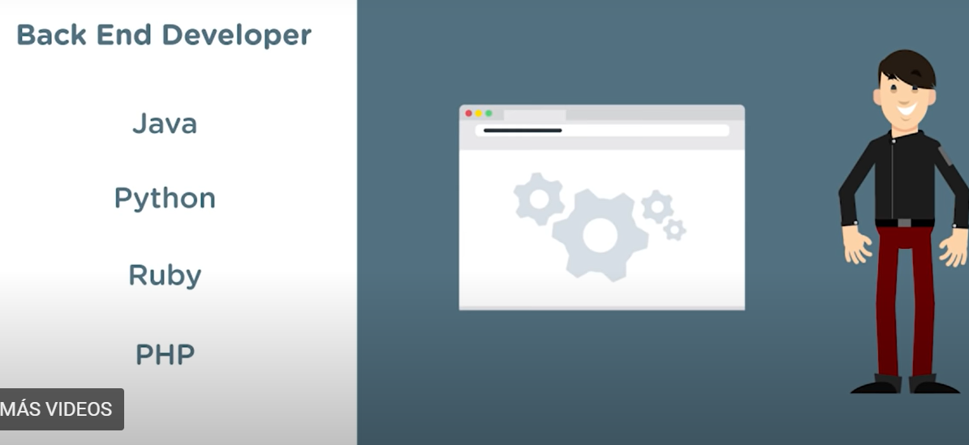

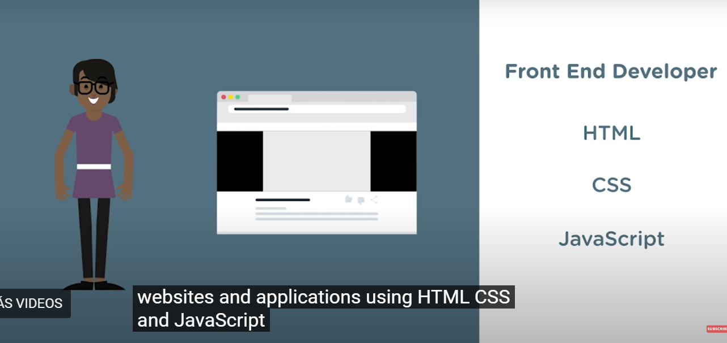

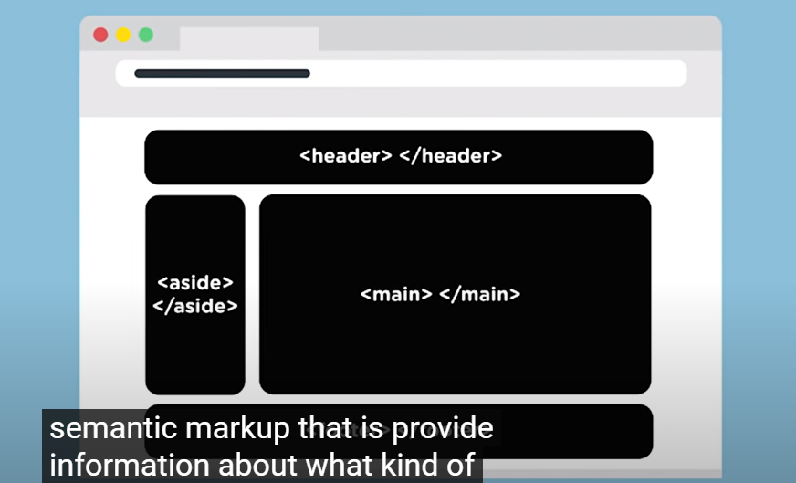

* **For images:**

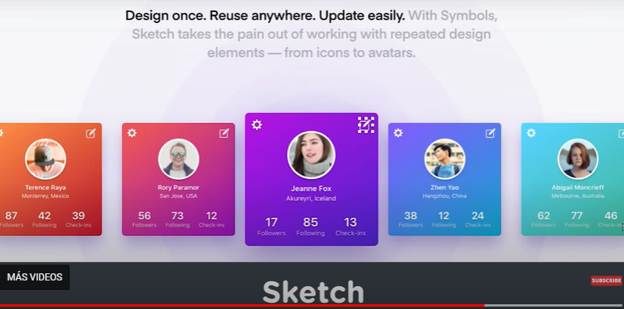

* **For wireframes:**

IMPOURTAN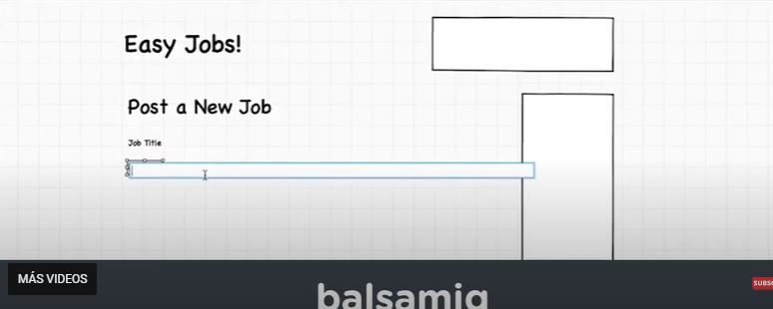

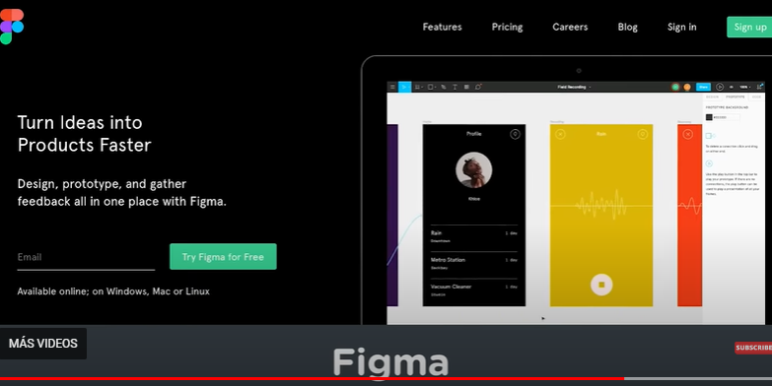

* **IMPORTANT:**

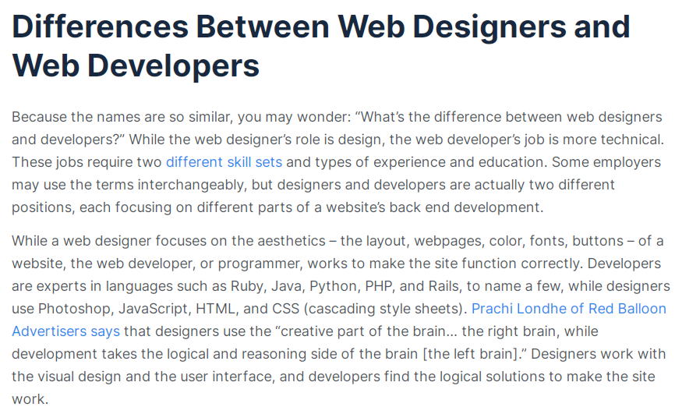

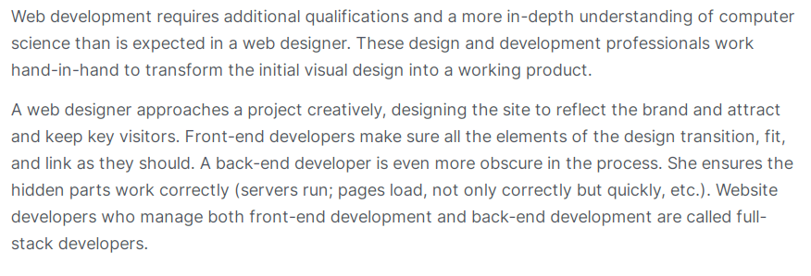

* Backend Web Developer.
* When we use the different units of measurement we should type the number and with no space the unit, example below:

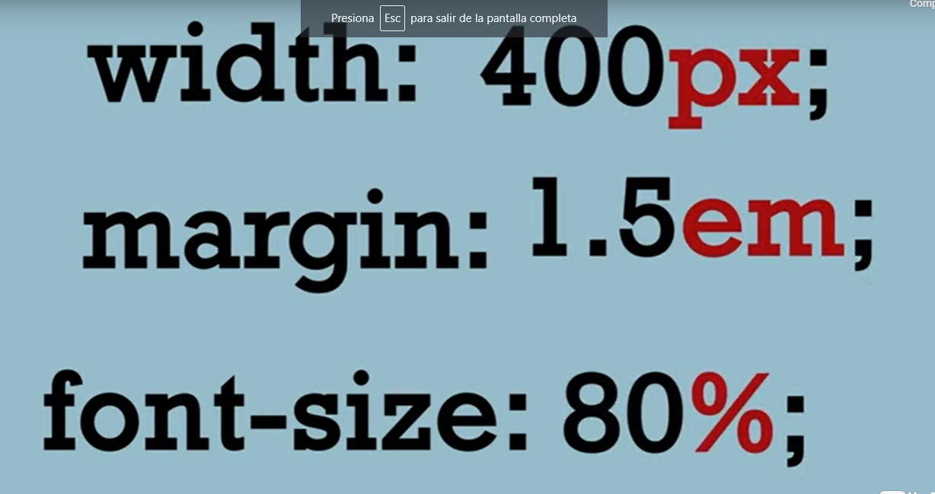

* **Responsiveness** is the way we do our programs, a good responsiveness is for example that an image display correctly in different devices, when we use a relative unit of measurement we can scale better our images, example below:

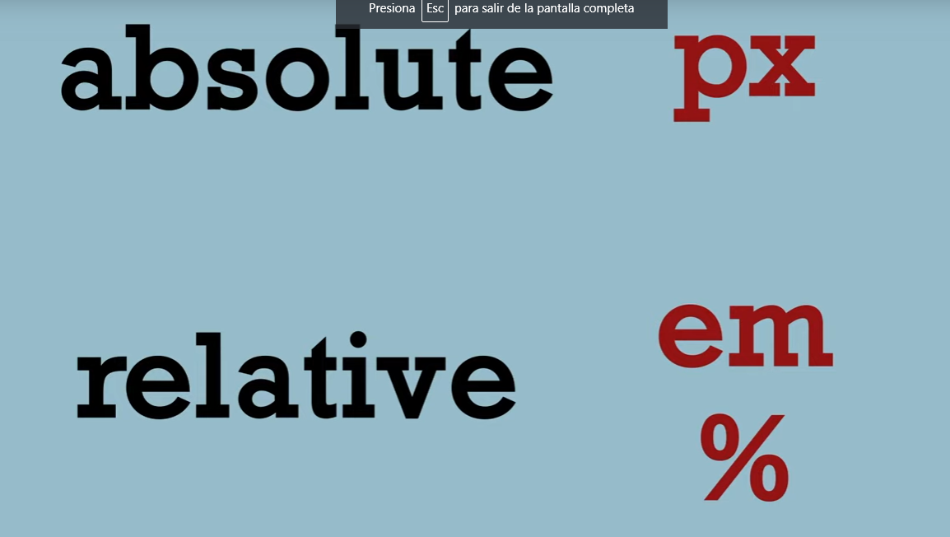

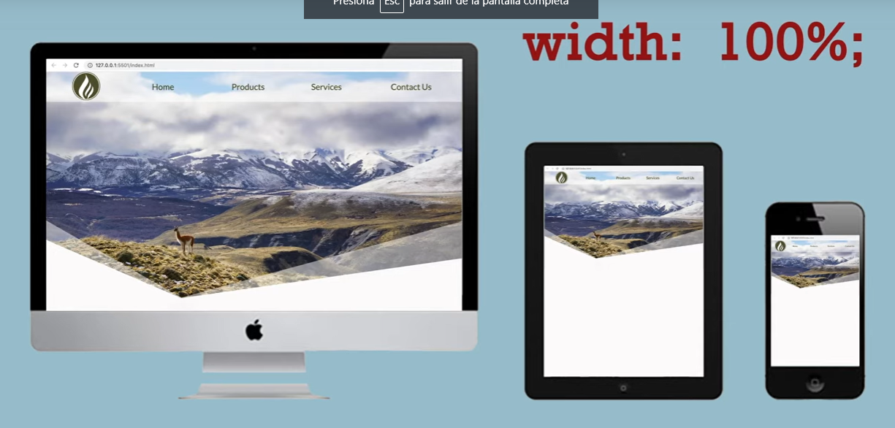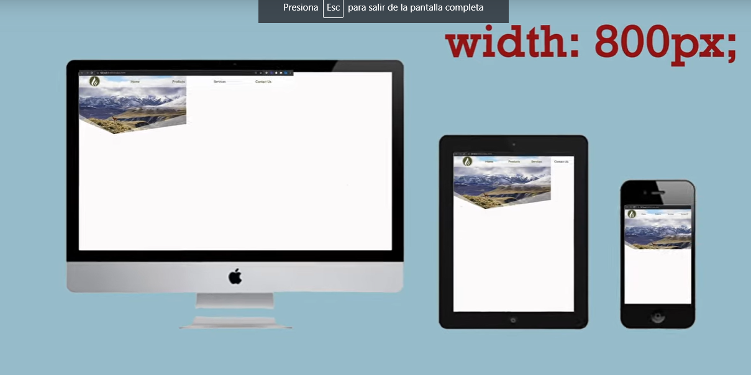

* **“em”** can be used to change different elements like: Fonts, Margins, Heading, etc.
* Remember that **1em = 24 px.**

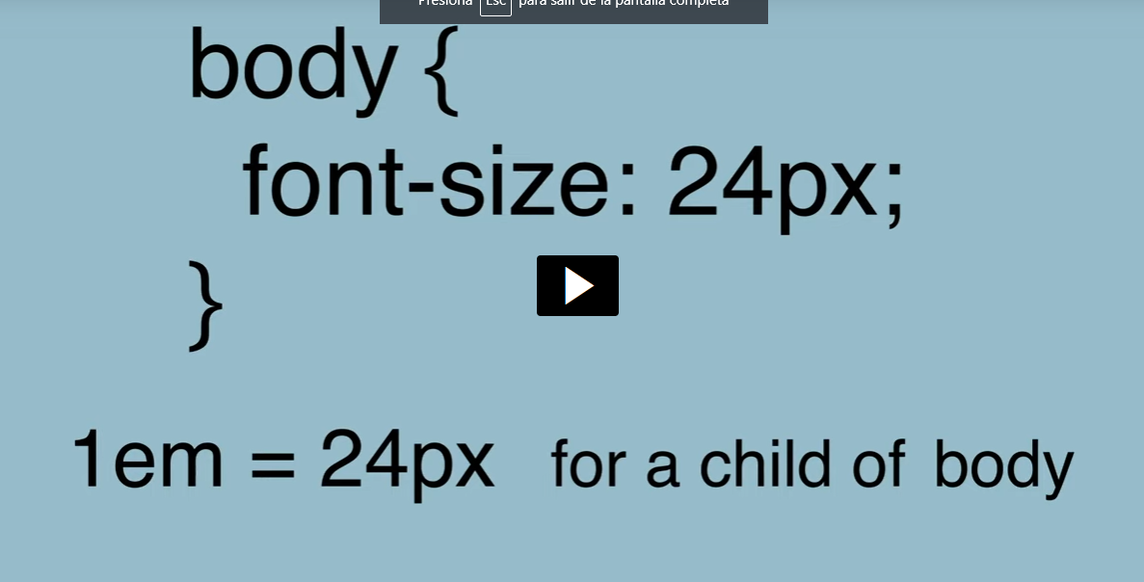}

* **W3schools.com** is a great source to learn everything about programming.

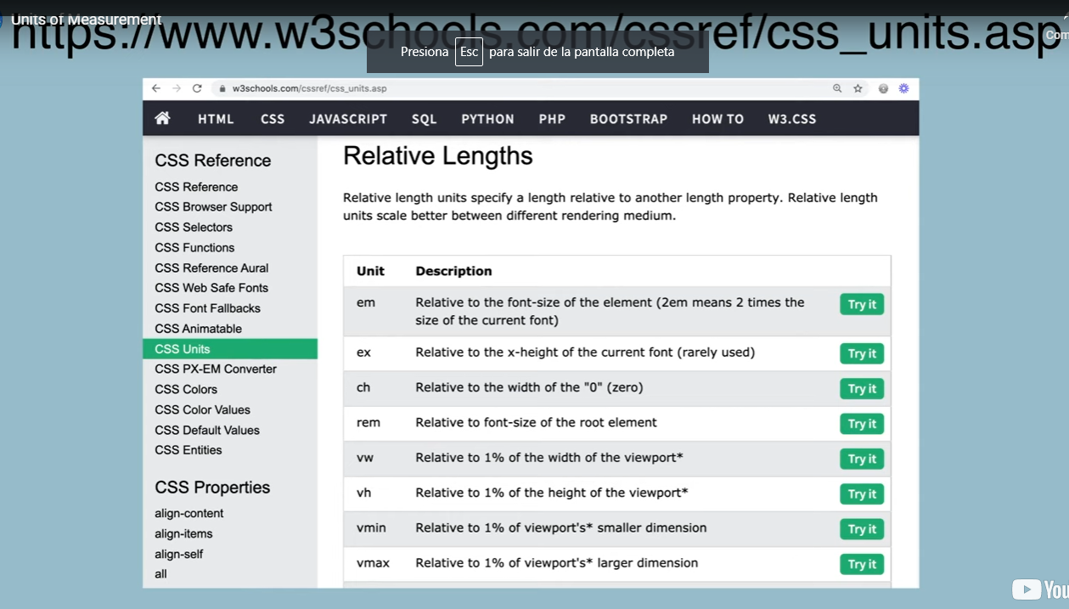

* **Good tip:**

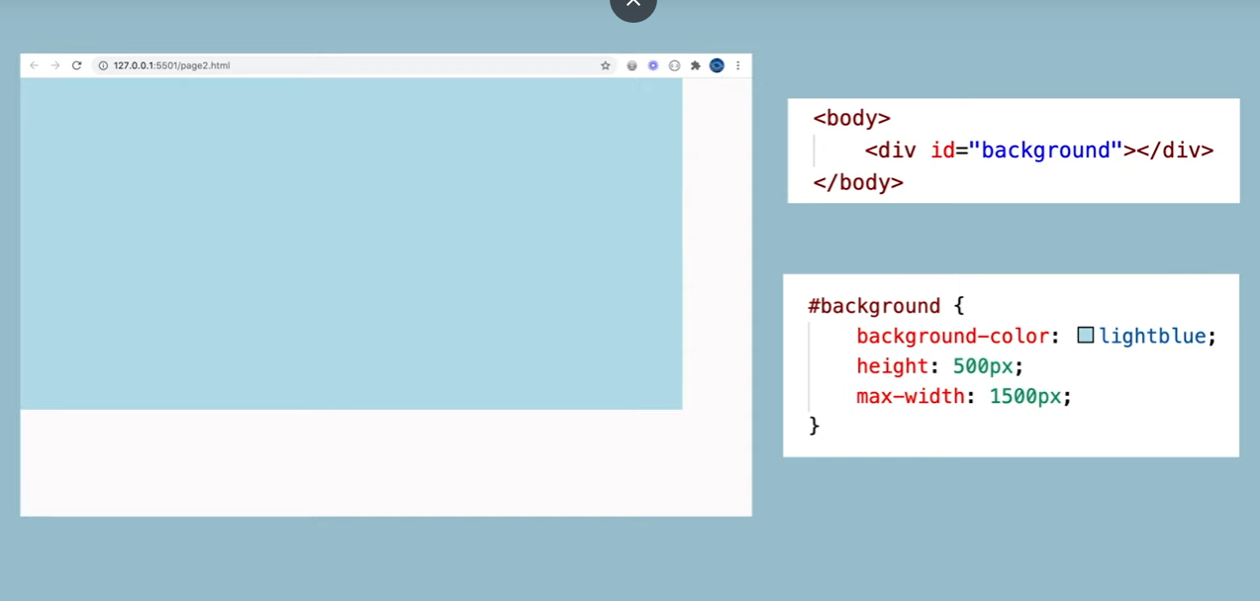

* **IMPORTANT:** It’s always a good idea to check out your website in all the possible different devices.

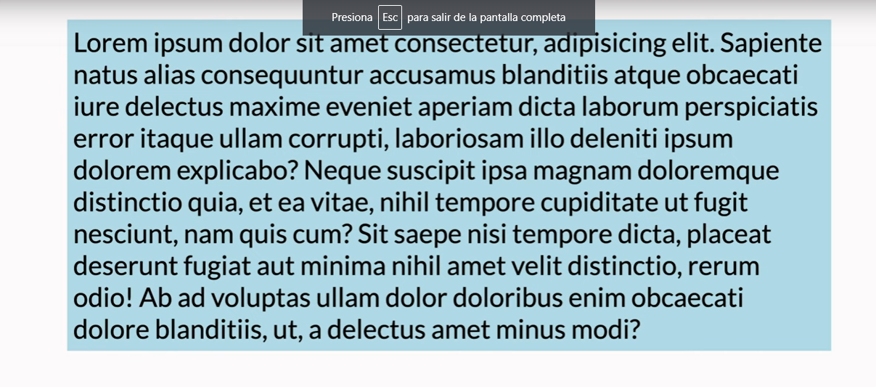

* **Block or inline element:** Block element go as far as they can, they take 100% of the page is like every element take a paragraph or a line, inline element is willing to share the line with other elememt, may with no jump.

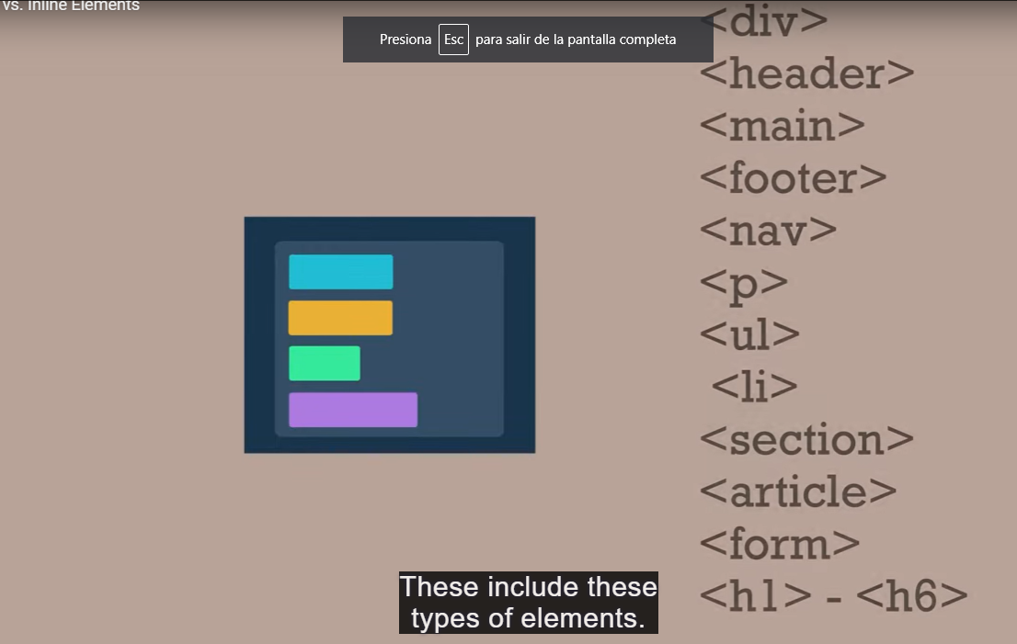

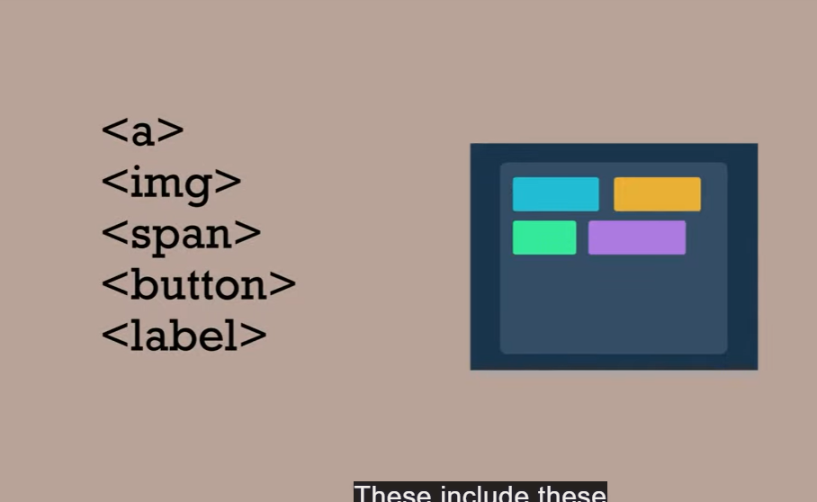

* **Block element example:**

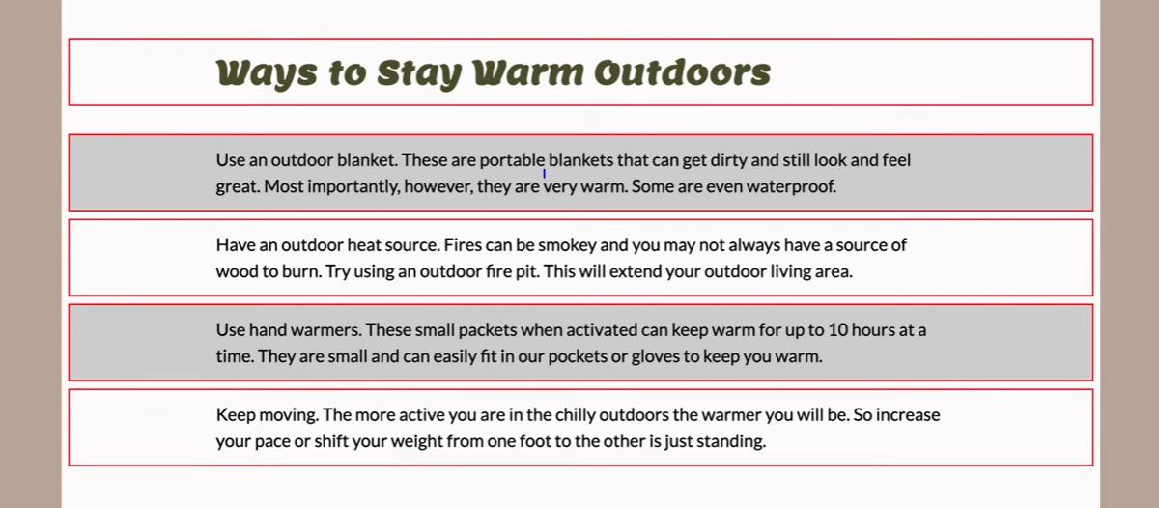

* **However if we placed images side by side, as lons as there is a room they will share the horizontal space available:**

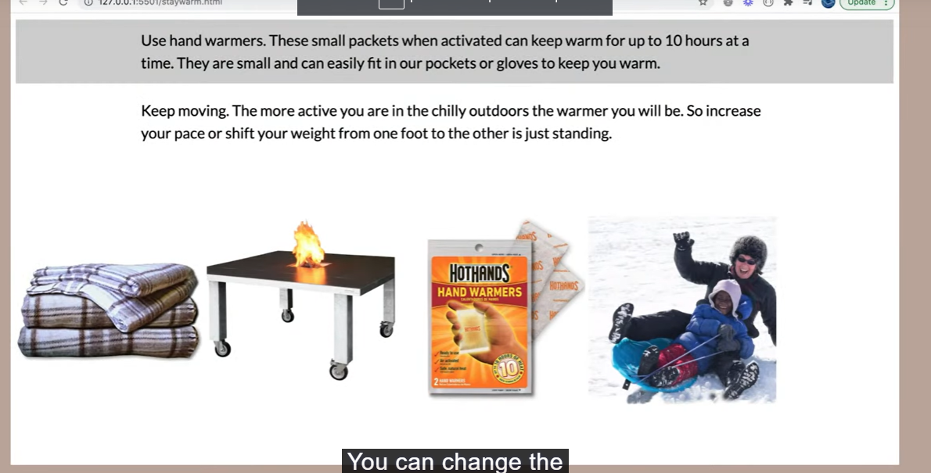

* **Display declaration , you can declare how you want to display certain information, example below:**

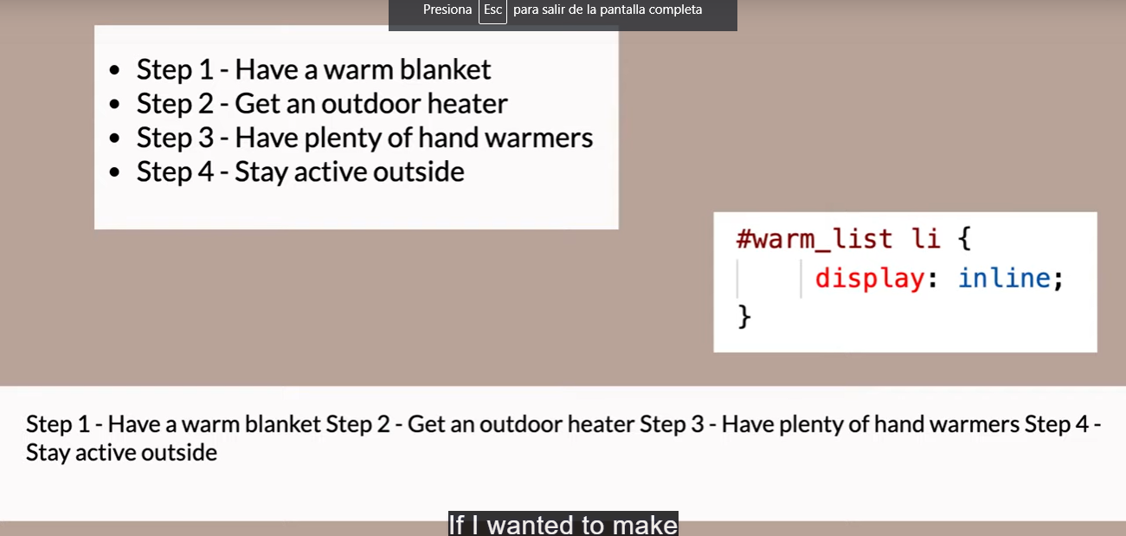

**Or**

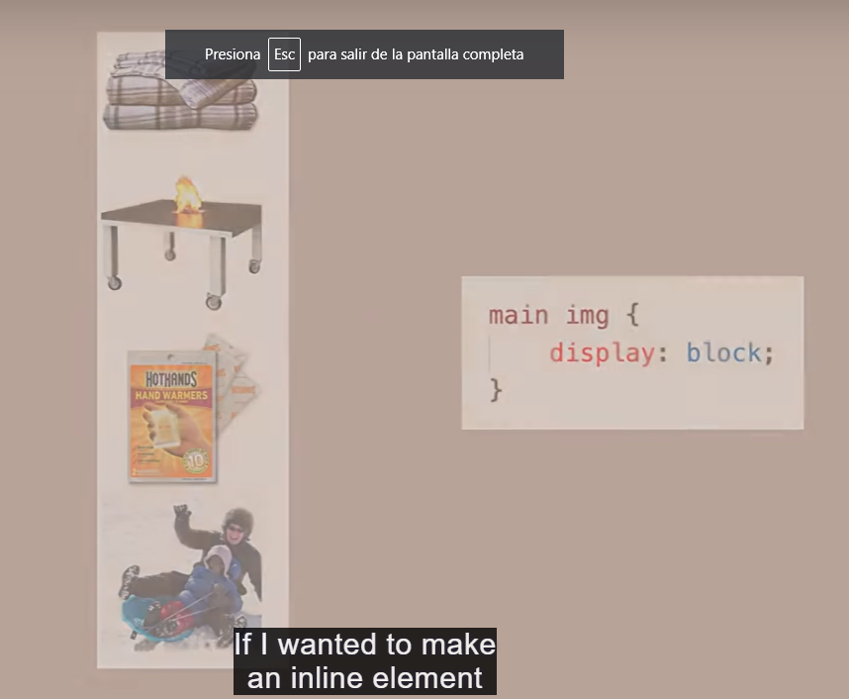

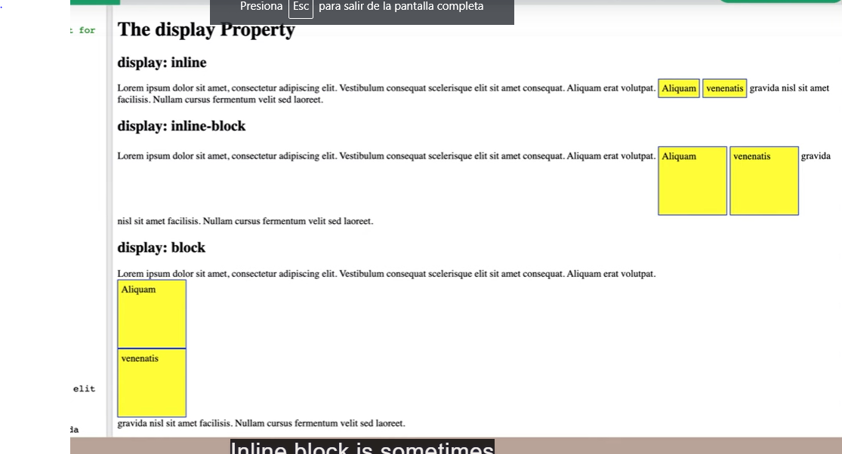

* **Text align center,** make the text centered in the box.

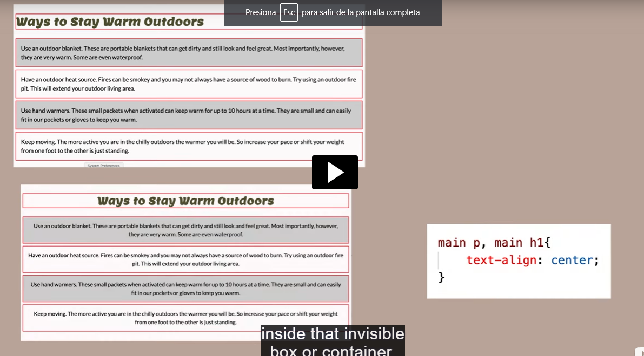

* In the image below the text inside the box is centered but using the 0 auto margin you can center the box by itself, example below:

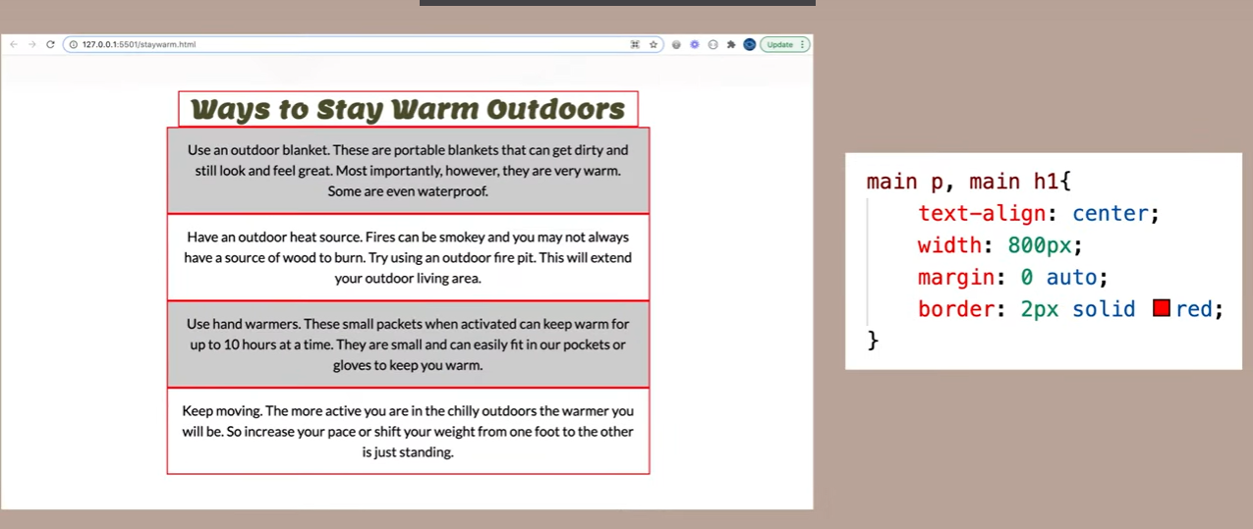

* **How to center an image:**

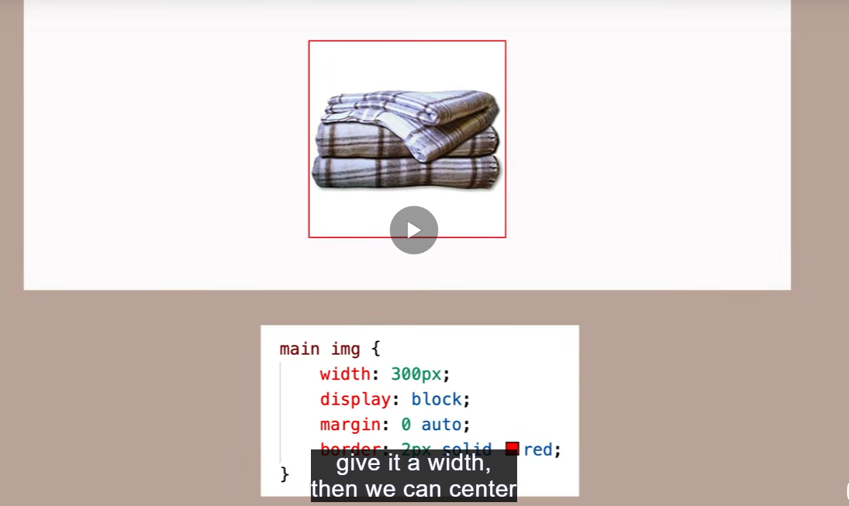

**Or**

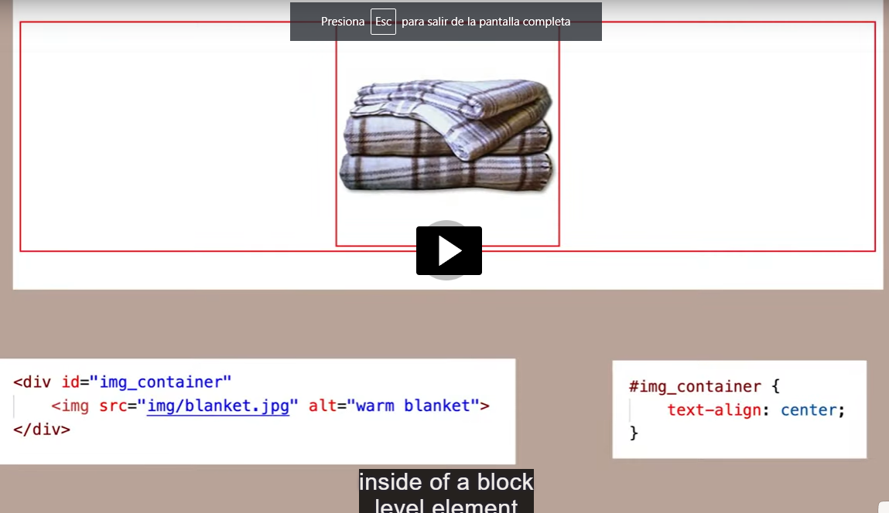

* The body has a font family declaration, but after that there is a more specific instruction “H1” so all thw body will have a font but “H1” would be different, example below:

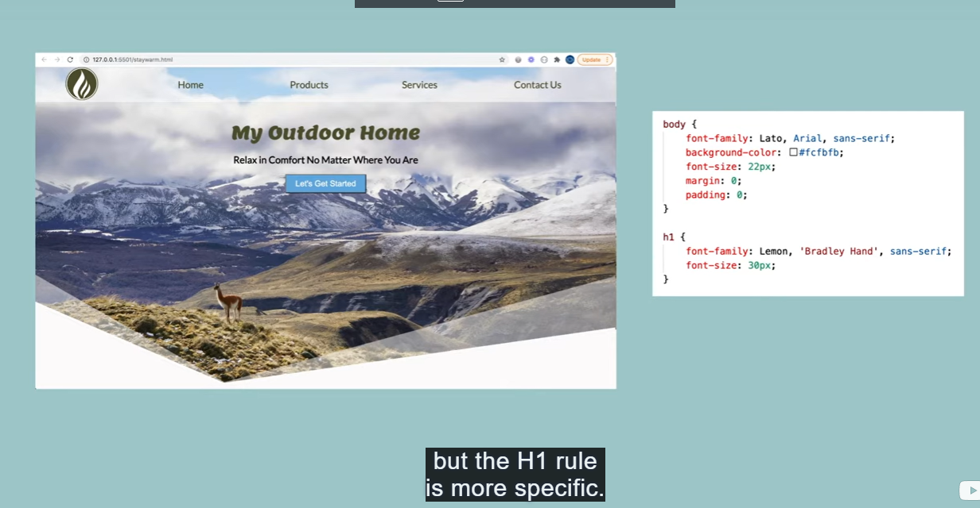

* **Hierarchy of the selectors in CSS are** the following #1 id’s, #2 classes, #3 elements, remember that doesn’t matter if the id is the firs line of the code and element is the last one, the instruction that would be followed would be the id instruction.

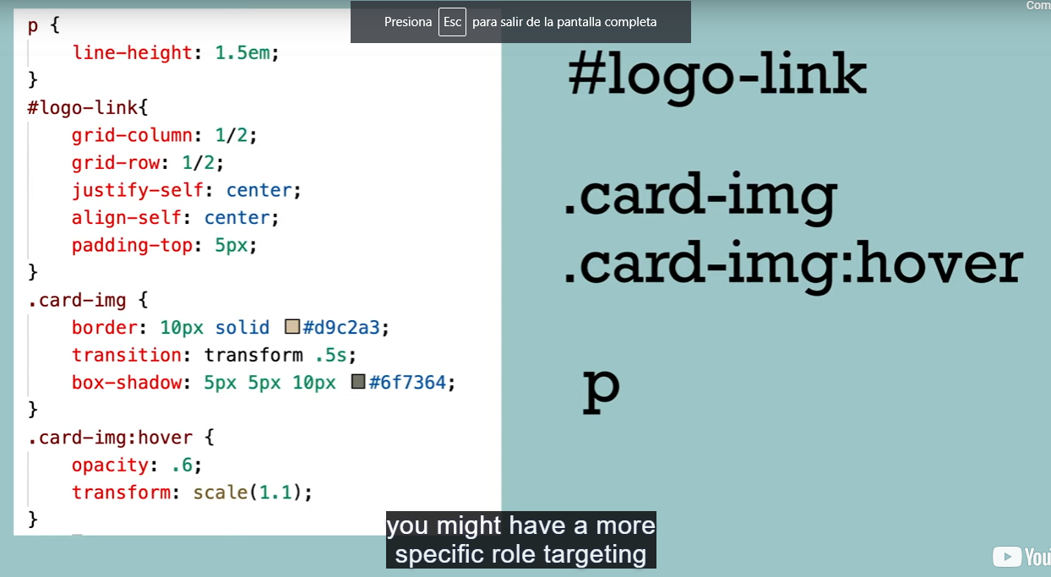

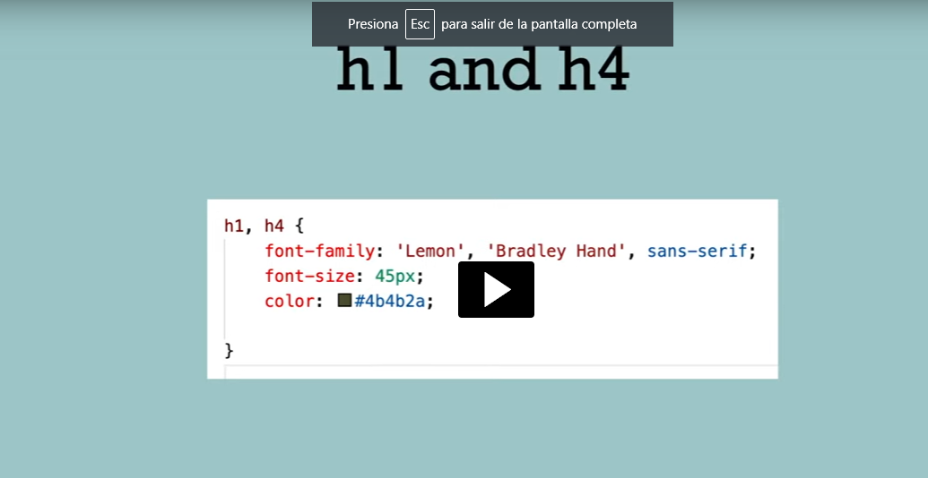

* **A decendent selector can be use to select many element inside “selector” at the sime time, example below:**

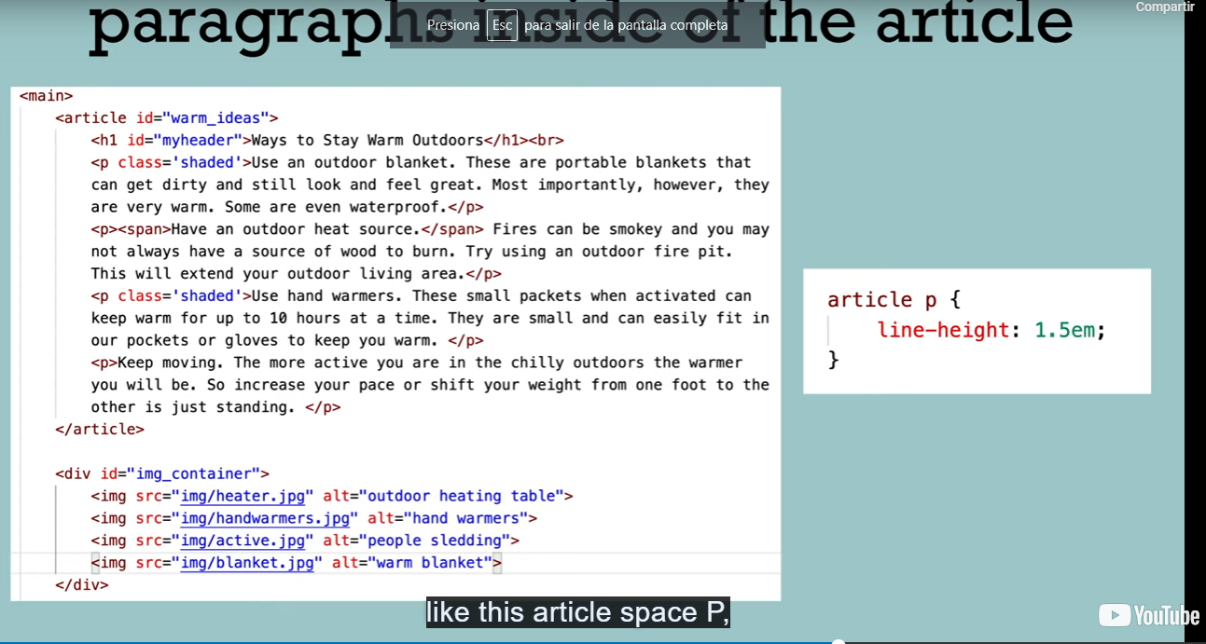

* **Good tip: You can use a “:havor” in your selector to display a background color when the user stay over a place, example below:**

